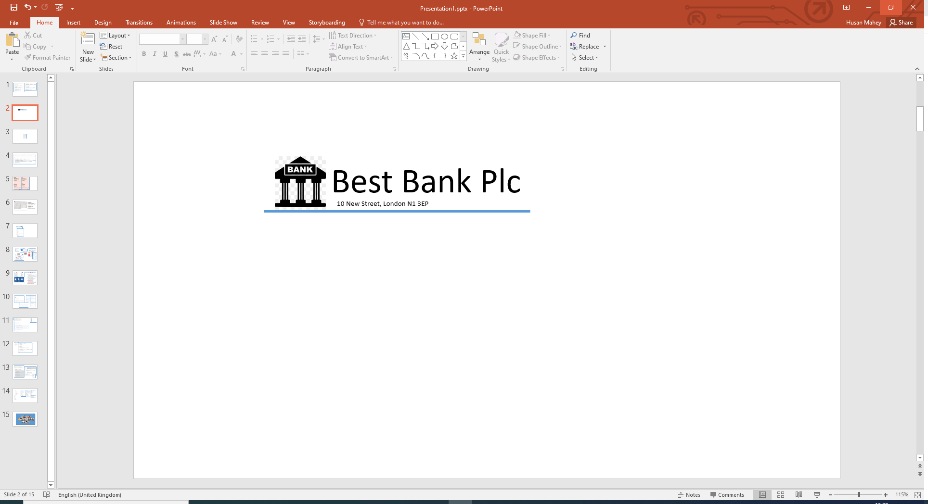

Mr Roger Day

7 Richmond St

Hilton

Aberdeenshire

AB24 2RR

Our Ref: Q302

Dear Roger,

Congratulations! Based on the information provided by you, we are pleased to inform you that you have been pre-approved for your recent loan application.

**Loan Details**

Amount: £ 4,000.00

Term: 36 months

Interest Rate (APR): 8.50%

Total Payable: £ 4,524.48

Monthly Payment: £ 125.68